Name:

ID:

M1 Computer Project

Email completed project: nps.assumption@gmail.com

Use Google Slides, Google Sheets, and Google Forms to create a project.

Step 0) Think of interesting data that you can collect from your classmates and generate a hypothesis about the data. This must be appropriate.

Example:

Data: Heights, Weights, Birthday

Hypothesis: People born in spring are shorter and have a higher weight

Step 1) Create the Survey with [Google Forms](https://docs.google.com/forms/u/0/). Your survey must have at least 3 questions.

Example:

What is you height?

What is your Weight?

What is your birthday?

Step 2) Get at least 10 people to take your survey.

Step 3) Create a spreadsheet from your survey.

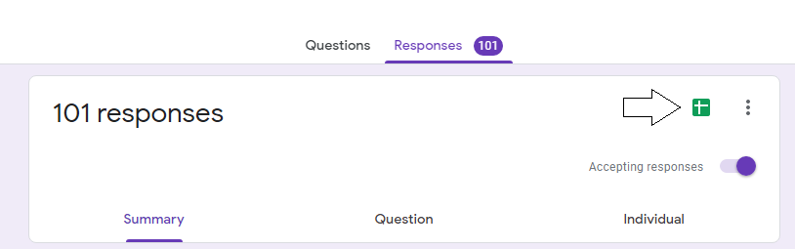

Step 4) Analyze the data in your spreadsheet.

* Calculate the mean, median, mode, and range for each question.
* Make a chart from the answers.

Step 5)

Create a [Google Slides](https://docs.google.com/presentation/u/0/) presentation about your survey. What conclusions can you draw from your data? Talk about your hypothesis, do you still agree with it? Also do research online and include additional information that you find online. Your presentation should be at least 10 slides, have images, and look professional.